

Technical Requirements

Real Estate Website using Rails

Client: Nichola Kerr (Client Contact)



April 26, 2016

Company: PropertyDome

Author: Daniel Swain

Contents

Document Signoff 2

Executive Summary 3

TechnicalObjectives 3

Site Overview 3

Hosting 3

Wireframes 3

Mockups 3

Functional Requirements 3

Information Hierarchy 4

Constraints 4

Critical Requirements for the Developers 4

Technology 4

Development Technology 4

Hardware and Software Requirements 4

Licencing 4

# Document Signoff

Revision: 1

Client: _______________________

Company

__ __ _______

Name Signature Date

Project Manager: Propertydome ___

Company

__ __ _______

Name Signature Date

Author: Propertydome ___

Company

__ __ _______

Name Signature Date

# Executive Summary

The client brief is to design, build and deploy a real estate website where users can search for and upload houses for sale using a set list of criteria as detailed in the functional requirements.

House posts are to be valid for 8 weeks, after which they expire and are flagged for removal from the database by the admin.

User uploads allow for 10 images in a free tier, with extra features unlocked by payments which are outside of our scope. User uploads are held in staging for review by admin prior to being searchable on the site.

# TechnicalObjectives

The technical objectives are as follows:

* Real Estate Website built using Ruby on Rails
* Database using MySQL
* Application to follow approved coding standards
* Application to meet functional requirements whilst meeting these technical objectives.

# Site Overview

## Purpose

The goal of this Real Estate Website is to allow users to upload and list their properties for sale without requiring an agent and at a lower cost (potentially free) than the current competition

## Timeframe

The site is to be built, tested and deployed live by the 9th of June 2016

Target Audience

The target audience includes private sellers and buyers as well as real estate agents and agencies with large amounts of listings.

## Hosting

The website will be hosted on Central’s ‘Web24’ Server at Central Tafe, with the database using MySQL.

# Wireframes

## Mock-ups

The following mock-ups represent the pages a user would see when listing and managing their property listings.



Sell index page, shown when you visit the sell URL with no listings.

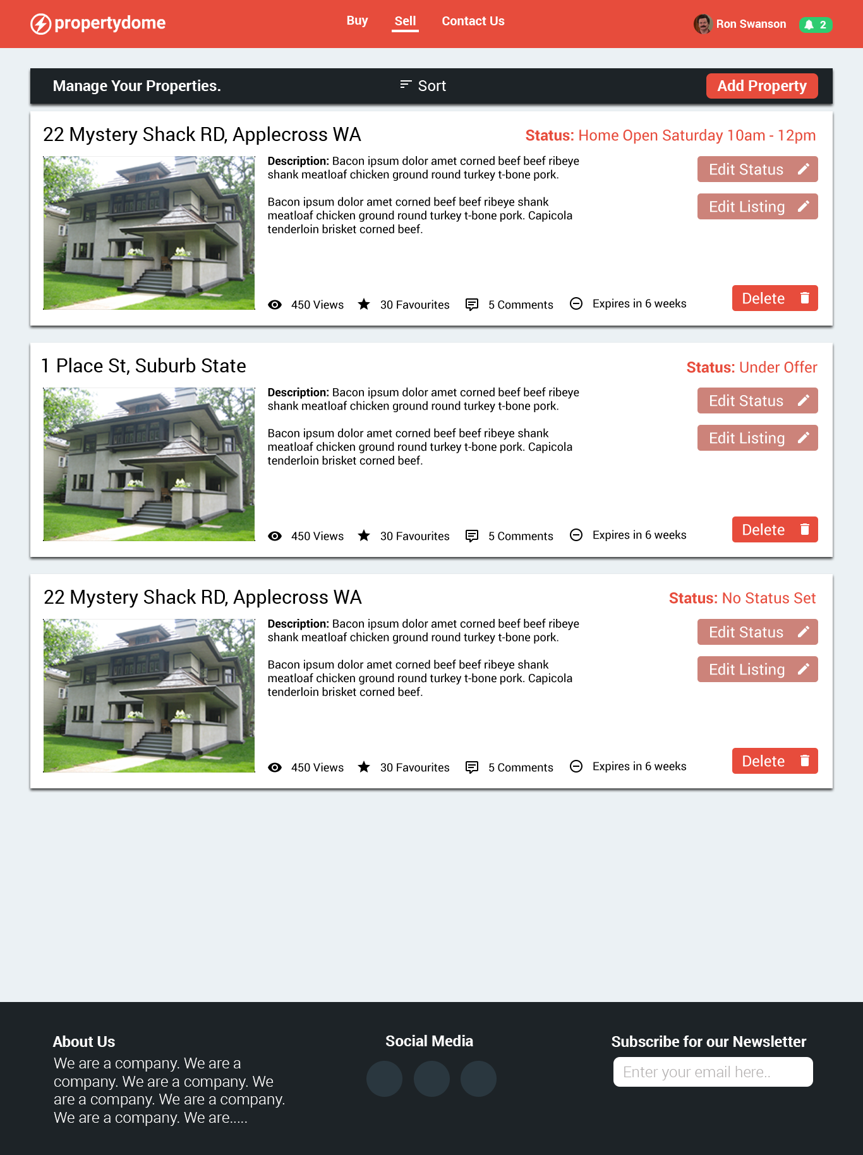

Sell Manage Page: Showing the property listings tied to your account for you to manage them (i.e. edit their status, edit the listing, and delete the listing). Listing stats are also shown (i.e. listing views, comments, favourites and expiry date)

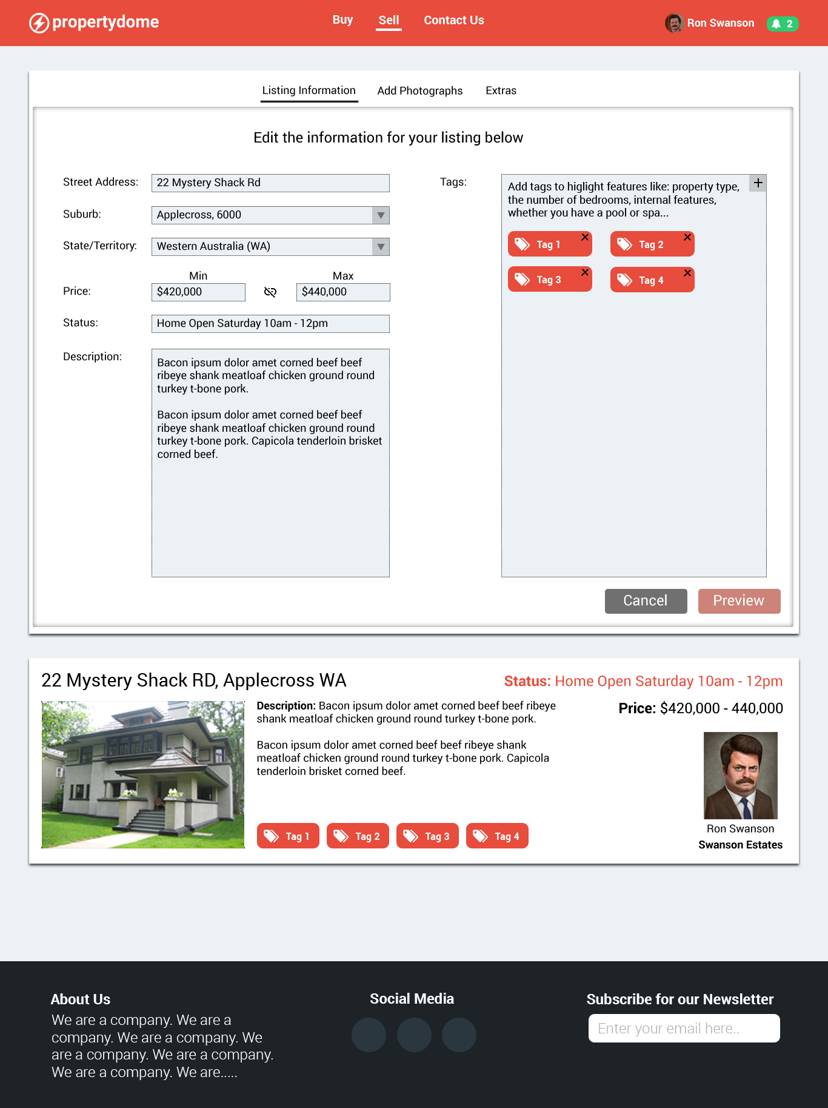

Add/Edit Listing Page: A tabbed page providing forms for adding or editing information for the users listing

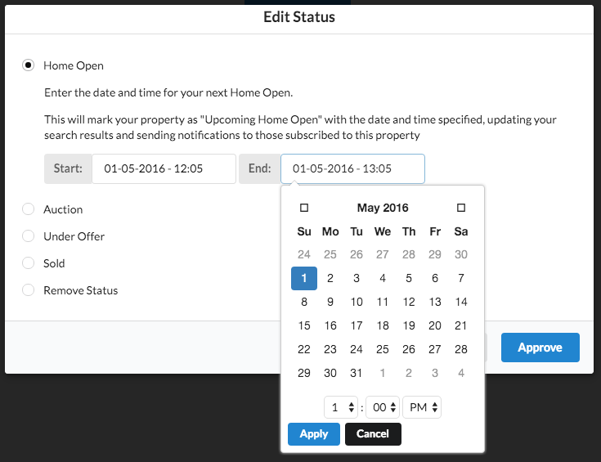

Edit Status Modal: A simple modal allowing users to edit the status of their listing which is sent to the users who have favourited that property.

## Functional Requirements

The following are the functional requirements to satisfy the client scope:

* Design, construction and deployment of a site with a simple interface for people to search for houses to buy and/or upload their own content and images of their house(s) for sale to a central database using the following criteria:
  + Location: Suburb/State
  + Price: Min/Max/Range
  + Bedrooms: Min/Max/Number
  + Property type: House/ Apartment/Land/Other
  + Bathrooms: Min/Max/Number
  + Car Spaces: set number in list
  + Min Land: sq.
  + Indoor features: Air con/ Alarm / etc.
  + Outdoor features:  Garage/ Swimming Pool/ Spa/ etc.
* Website to work on latest version of major browsers (Chrome, Firefox, Safari, Internet Explorer) and be responsive on major mobile devices (iPhone 5, 6, 6+; Android phones with similar screen sizes 5 - 6”)
* Each house posting to last up to 8 weeks after which they are expired and flagged for removal via an admin, unless a payment is made by the user to extend the post (Payments outside of scope).
* Provision for users to upload 10 images for free. Whilst not part of our scope, extra image uploads and listing features will be able to be unlocked via additional payments by users.
* An admin interface shall be provided for staff to approve user uploads prior to their appearance on the main site.

## Information Hierarchy

The following represents the proposed hierarchy for the Real Estate Website:

* Index Page
  + The index page introduces users to the website and shows statistics if not signed in
  + If signed in a user will see their favourited properties on the index page
  + A company twitter feed will be shown on the index page
  + Featured properties are also shown on the index page, and provide a potential avenue for monetisation
  + The index page contains a search field which will send the query to the search page
* Sell Pages
  + The main sell page shows a ‘why you should sell with us’ advertising view if not logged in or logged in with no listings.
  + If the user has listings they will see their listings in a manage listings view
  + An add/edit page is where users will update or add a listing to the website
* Contact Us Page
  + A dedicated contact us form
* User Dashboard Page
  + The user dashboard page shows all the user activity
  + The user can edit their settings (notifications, password, username)
  + The user can view their favourited properties
  + The user can see and respond to any of their messages
* Property Page
  + The property page shows the property listing view and is what will be shown to a user when clicking on a search result
* Search Page
  + Shows search results and allows users to edit their query
* Seller’s Listing Page
  + Show all the listings for the seller (not for management, but to see other listings they might have)
* Static Pages
  + Terms and conditions
  + Privacy Policy
  + About Us
  + User login/signup pages

## Constraints

The following represents the constraints for the project:

* Development for this project will take place at Central TAFE, this will include hosting the website on Central’s ‘Web24’ Server. Due to the server environment, the project will not be able to support anything that the current Central server cannot.
* The database will have to be ‘MySQL’ as this is what the Central Web24 server runs. All development/testing/prototyping will be designed to work for MySQL.
* The project is to be built using Ruby on Rails
* The project is to be completed by the 9th of June, 2016. This deadline may restrict additional features or last minute changes to the project.

### Critical Requirements for the Developers

The critical requirements for the developers are the same as the above constraints. Developers will need to test their work to ensure compatibility with Central’s Web24 server and the versions of Ruby and Rails installed.

# Technology

## Development Technology

The following tools and development technologies will be used

* **Ruby on Rails:** Development environment (including Sass, HTML and JS)
* **MySQL:** Database technology
* **Slack:** Communication tool for team members
* **Trello:** Project Management tool and monitoring.
* **Zapier:** Used to link various tools together and notify Trello when there’s a GitHub issue or notify slack when there’s a Trello card added.
* **Github:** For version control and software management

## Hardware and Software Requirements

For testing and development the following hardware and software are required:

* **Chrome/Firefox/Safari/IE/Edge:** Browsers required for testing
* **Rails 4+:** The web framework minimum version
* **Sublime 3:** The recommended text editor for development
* **Ruby 2.2+:** The minimum Ruby version for development

# Licencing

The application and website is the property of the client and will be transferred to their version control management software and server upon completion of the project.

Any open source libraries or tools used are to be properly attributed using their appropriate Open Source Licence (i.e. MIT, GNU, and Apache).